Steps to run the application on local R-studio.

1. Unzip the folder
2. Open app.R.
3. Install all the required packages:
   1. “shiny”
   2. “dplyr”
   3. “purrr”
   4. “purrrlyr”
   5. “tm”
   6. “snowball”
   7. “openNLP”
   8. “NLP”
   9. “hunspell”
   10. “stringi”
   11. “stringr”
4. Click on Run App.
5. 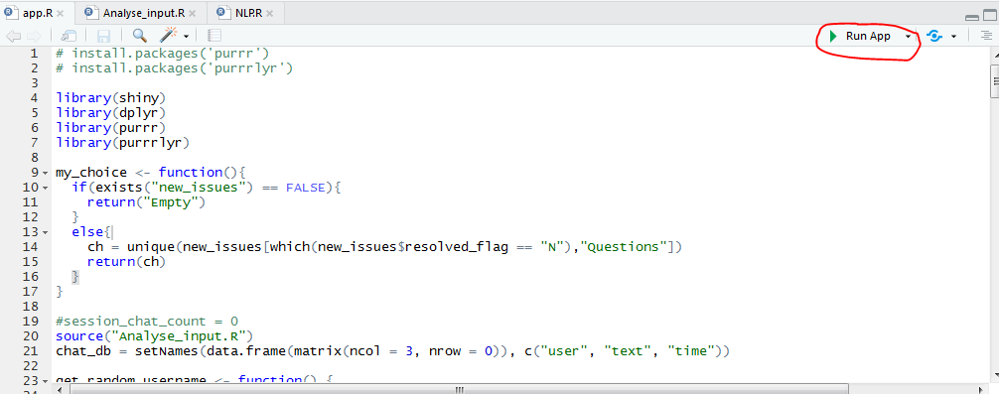
6. Below window will open.
7. 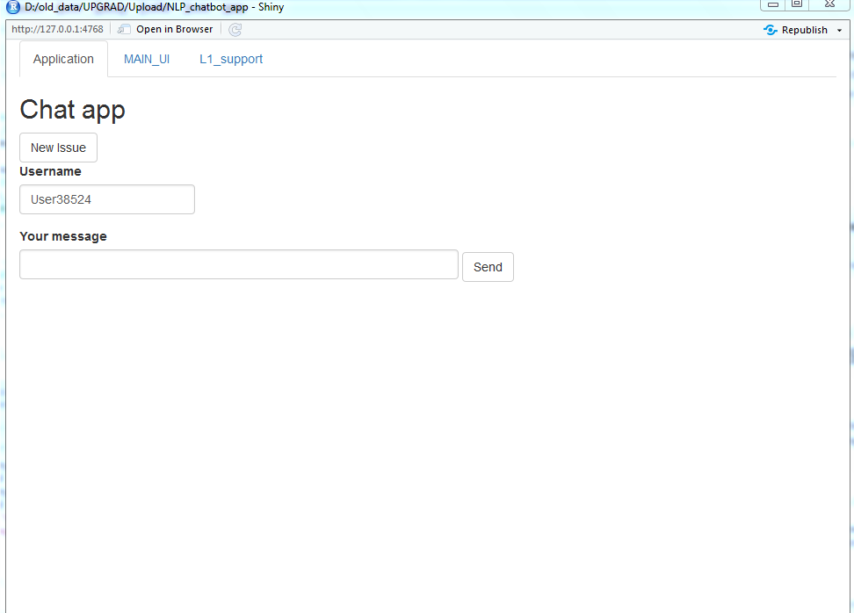
8. The app has 3 tabs:
   1. Application
   2. MAIN_UI
   3. L1_support
9. Go to second tab “MAIN_UI” for first time training or retraining.
10. 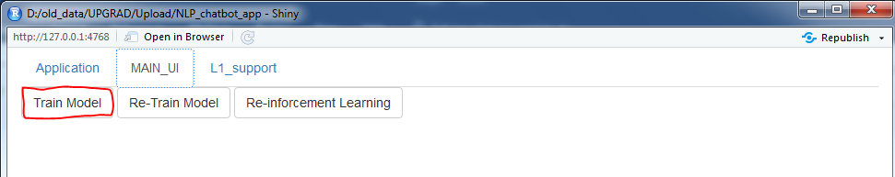
11. Press “Train Model” for first time training.
12. Wait for few seconds for the process to finish.
13. Go to first tab “Application”
14. Enter a greeting word (Hi, Hello) to initiate the bot.
15. Bot will ask for the issue.
16. Enter your issue and press send.
17. If there is any solution present related to your query, bot will provide the solutions 1 by 1.
18. Type 1 and send to see the solution.
19. If the solution is not pertaining to your query, type 0 and send.
20. If there is no solution, system will raise an automatic ticket.
21. 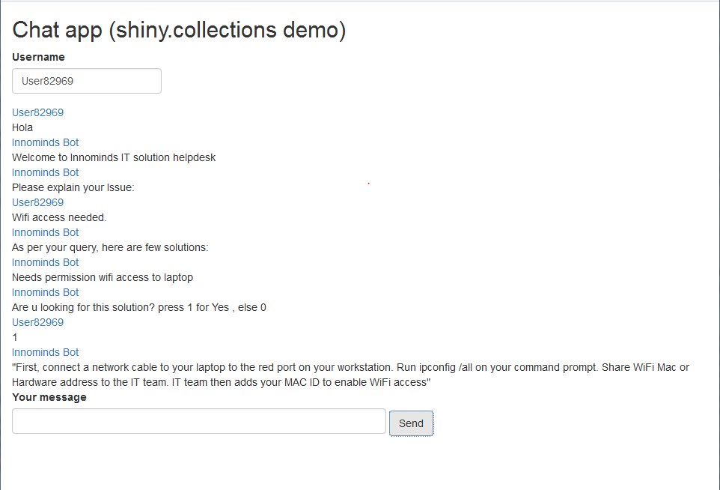
22. 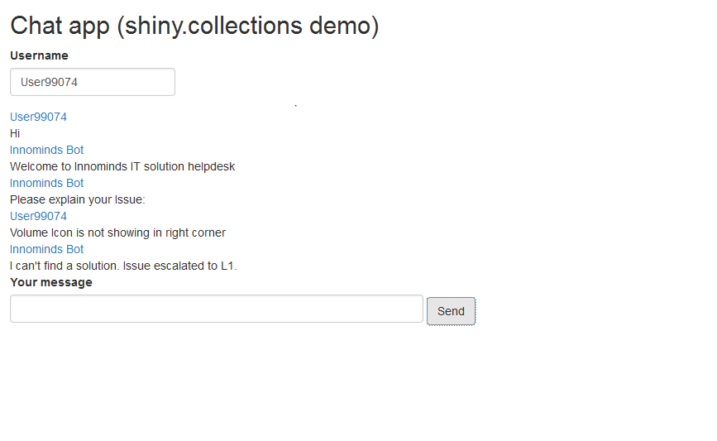
23. You can press “New Issue” button to ask new query.
24. 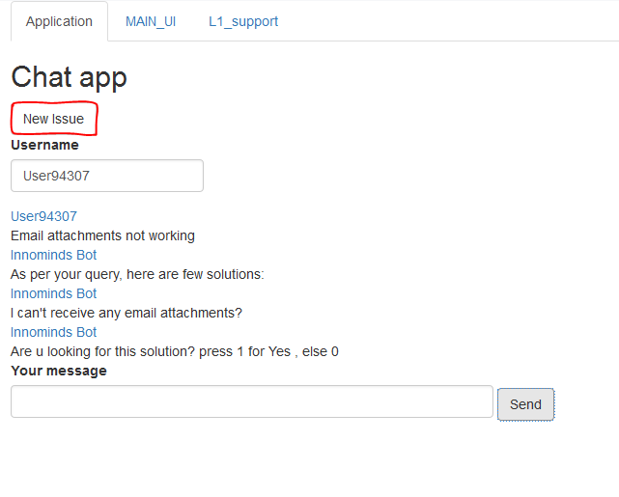
25. For new Issues raised by the system, L1 support must resolve the tickets to provide solutions to non-existing problem.
26. Switch to third tab “L1_support” to resolve a new issue.
27. New issues will be shown in the drop down.
28. Select an issue.
29. System will detect and show the entities.
30. Select the proper entities.
31. Provide a resolution and press “Submit”.
32. 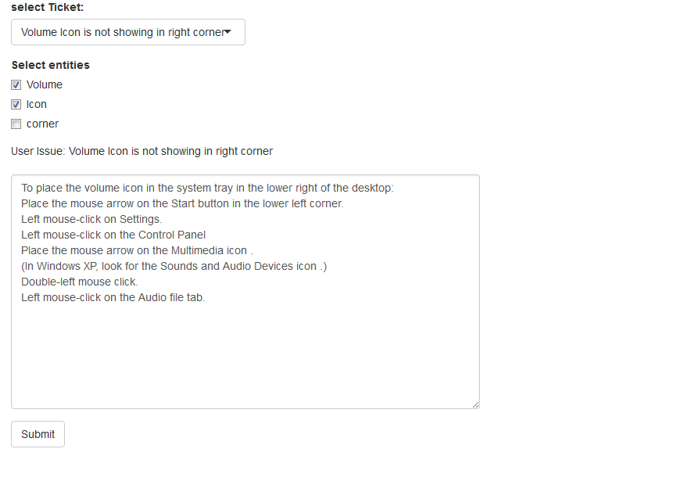
33. Go to second tab “MAIN_UI” and press Re-Train model to retrain with the new set of queries and solutions.
34. Switch to “Application” tab and test for the new queries. This time system will provide the solutions as entered by L1 support.

THANKS